Chapter 3, Solution 56

Determine v₁ and v₂ in the circuit of Fig. 3.101.

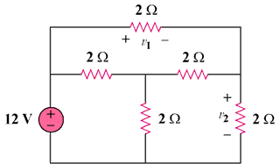

Figure 3.101
For Prob. 3.56.

Solution

–
+

12 V

i₁

i₂

i₃
+
v₂
–

+ v₁ –

2 Ω

2 Ω

2 Ω

2 Ω

2 Ω

For loop 1, 12 = 4i₁ – 2i₂ – 2i₃ which leads to 6 = 2i₁ – i₂ – i₃ (1)

For loop 2, 0 = 6i₂ –2i₁ – 2 i₃ which leads to 0 = -i₁ + 3i₂ – i₃ (2)

For loop 3, 0 = 6i₃ – 2i₁ – 2i₂ which leads to 0 = -i₁ – i₂ + 3i₃ (3)

In matrix form (1), (2), and (3) become,

Δ = Δ₂ =
Δ₃ = , therefore i₂ = i₃ = 24/8 = 3A,
v₁ = 2i₂ = 6 volts, v = 2i₃ = 6 volts

